Empowering Horizons
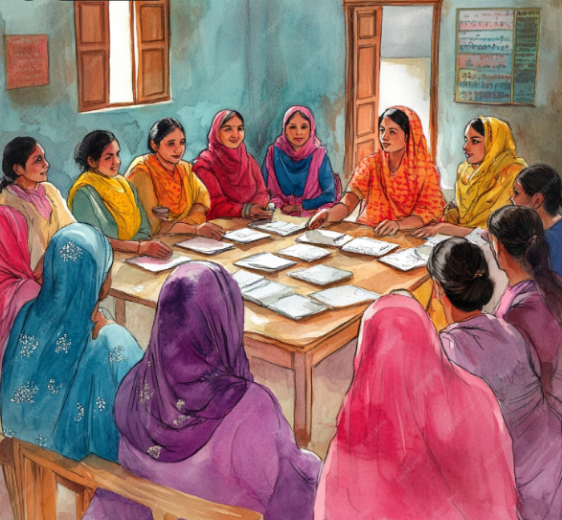
Theme: Educate • Empower • Elevate
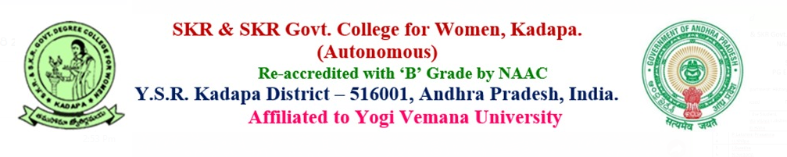
THE SKR&SKR COLLEGE FOR WOMEN 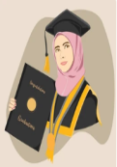(A), KADAPA.
2025-2026
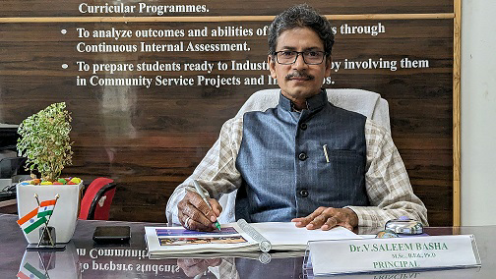
Dr.V.Saleem Basha, M.Sc.,B.ed.,Ph.D.
PRINCIPAL
Principal’s Message
It gives me immense pleasure to present the annual college magazine Empowering Horizons for the academic year 2025–26. This publication is not merely a collection of writings and creative expressions; it is a reflection of the vibrant spirit, intellectual curiosity, and boundless potential of our students and faculty.
The chosen theme for this year, “Illuminating Minds, Inspiring Futures”, beautifully captures the essence of our institution’s mission. Education is not confined to classrooms—it is a journey of discovery, empowerment, and transformation. Through knowledge, creativity, and resilience, our students are preparing themselves to become leaders, innovators, and compassionate citizens of tomorrow.
I congratulate the Department of English and the Literary Committee for their dedication in bringing together diverse voices and talents into this magazine. I am confident that Empowering Horizons will inspire readers, encourage dialogue, and serve as a beacon of motivation for all who turn its pages.
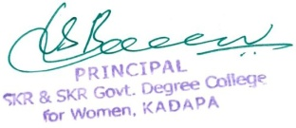
May this magazine continue to nurture creativity, celebrate achievements, and remind us that with education, empowerment, and vision, the horizons of possibility are truly limitless.

Editorial Note:
Empowering Horizons is more than a magazine—it's a celebration of intellect, creativity, and the transformative power of education. Rooted in the theme Educate • Empower • Elevate, this publication reflects the voices, visions, and vibrant spirit of our students and faculty. It is a platform where ideas flourish, stories inspire, and knowledge uplifts.
Achievement:
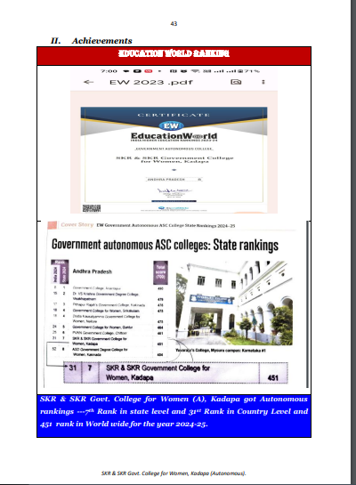

List of the Principals from 1973 to 2026:
S.No | Name of the Principals | From | To
1 | Sri.Major Md.Nadimulla .,M.A | 30.10.1973 | 19.9.1974
2 | Sri.K.Penchalaiah.,M.A.,M.ed(F.A.C) | 19.8.1974 | 2.12.1974
3 | Sri.Dayanidhi.,M.A. | 2.12.1974 | 7.2.1975
4 | Dr.Smt.A.Vanajakshi,M.A.,M.ed. | 8.2.1975 | 17.7.1975
5 | Sri.M.V.Ramanaiah,M.A., (F.A.C) | 17.7.1975 | 2.9.1975
6 | Sri.K.Madhava Rao.,B.Sc(Hons) (F.A.C) | 3.9.1975 | 10.2.1976
7 | Sr.J.R.Ramamohan Rao.,M.A. | 11.2.1976 | 5.6.1979
8 | Dr.Kum.Y.Padmavthi.,M.A. | 6.6.1979 | 13.7.1981
9 | Kum.M.V.Ranamma.,M.A.,B.ed. | 14.7.1981 | 28.2.1983
10 | Sri.W.Ragunath.,B.A (Hons) (F.A.C) | 28.2.1983 | 8.6.1983
11 | Sri.T.B.L.Narasimha Rao .,B.A. | 9.6.1983 | 25.12.1985
12 | Sri.M.S.Jagannatha Rao.,B.Sc.(Hone)D.T.E | 26.12.1985 | 5.10.1986
13 | Smt.G.Pullamamba.M.A.,B.Ed | 22.6.1986 | 15.7.1988
14 | Smt.O.Vijayalaksmi.,M.A., (F.A.C) | 16.7.1988 | 26.7.1990
15 | Smt.O.Vijayalaksmi.,M.A., | 27.7.1990 | 21.6.1995
16 | Smt.Y.Anasuyamma.,M.Sc., (F.A.C) | 1.6.1995 | 16.6.1995
17 | Dr.C.Ranga Reddy .,M.A.P.hD. | 5.11.1995 | 31.5.1995
18 | Smt.Y.Anasuyamma.,M.Sc., | 1.6.1996 | 16.6.1996
19 | Smt.B.Suryanarayanama.,M.Sc. | 17.6.1996 | 31.5.1999
20 | Smt.G.ParameswaraReddy M.Com.,(F.A.C) | 1.6.1999 | 2.7.1999
21 | Smt.Y.Anasuyamma.,M.Sc., | 3.7.1999 | 20.7.2000
22 | Sr.G.Paramesweswara Reddy.,M.Sc.,M.ed., (F.A.C) | 21.5.2000 | 31.8.2000
23 | Sri.T.Padmanabha Reddy., M.Sc., M.ed.,(F.A.C) | 1.9.2000 | 23.6.2001
24 | Sri.M.J.R.R.Issac.,M.Sc., | 24.6.2001 | 30.4.2002
25 | Sri.T.Padmanabha Reddy., M.Sc., M.ed.,(F.A.C) | 1.5.2002 | 6.2.2004
26 | Sri.S.Sultan Ahamed., M.Sc., | 24.2.2004 | 31.5.2004
26 | Smt.B.Srilakhmi.,M.A (F.A.C) | 1.6.2004 | 30.6.2004
27 | Sri.Radhakrishna Reddy., M.Sc., (F.A.C) | 1.5.2005 | 30.6.2005
28 | Smt.Dr.R.Anusuya.,M.Sc.,P.hd.,(F.A.C) | 1.7.2005 | 18.9.2005
29 | Smt.K.Malleswari.,M.com (F.A.C) | 19.9.2005 | 21.4.2007
30 | Sri.N.Viswanatha Reddy.,M.Com.,L.L.B. | 22.7.2007 | 31.7.2007
31 | Smt.N.Padmavathi.,M.Sc.,M.Ph. | 1.8.2007 | 2.9.2015
32 | Smt.Dr.P.Subba Lakshumma.,M.com.,M.Pih.,P.hD. | 2.9.2015 | 14.7.2023
33 | Sri.Dr.V.Saleem Basha.,M.Sc.,B.ed.,P.hD. | 14.7.2023

List of State Best Teacher Awardees:
S.No | Name of the Lecturer | Department | Year
1 | Dr.P.Subba Lashumma.,M.Com.,P.hD. | Commerce | 2009
2 | Dr.C.Subba Reddy.,M.Sc.,Ph.D. | Statistics | 2015
3 | Dr.Shazeeya Begum M.A., M.Phil.,Ph.D | Urdu | 2019
4 | Dr.P.Sachi Devi.,M.Sc.,Ph.D. | Zoology | 2023
5 | Dr.G.Vijay Lakshmi M.A., Ph.D | Economics | 2024

Dr.Shazeeya Begum, M.A., M.Phil.,Ph.D,Urdu 2019  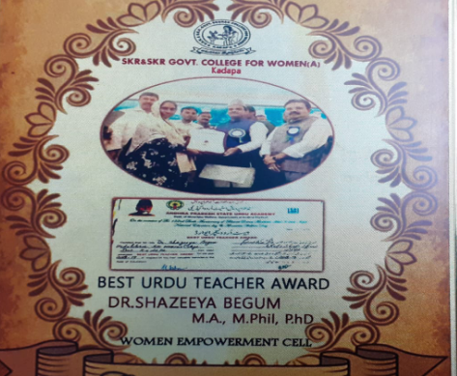 | Dr.P.Sachi Devi.,M.Sc.,Ph.D. Zoology 2023  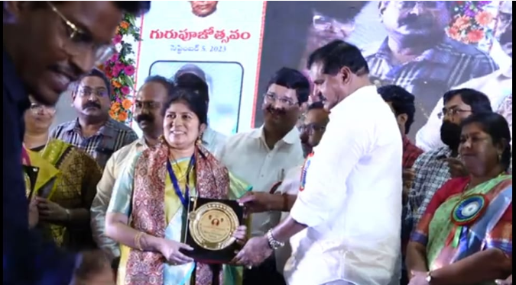
Dr.G.Vijaya Lakshmi , M.A., Ph.D.,Economics 2024  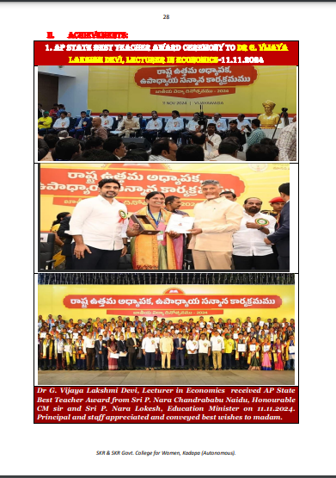 | 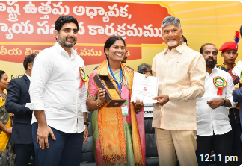

IQAC TEAM
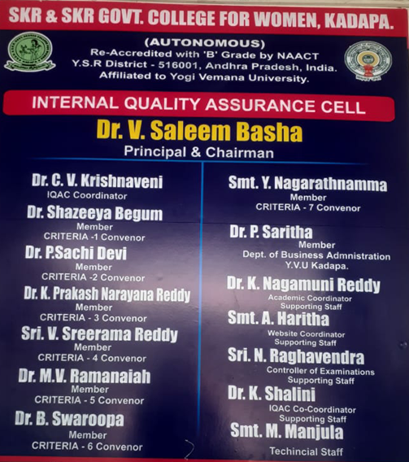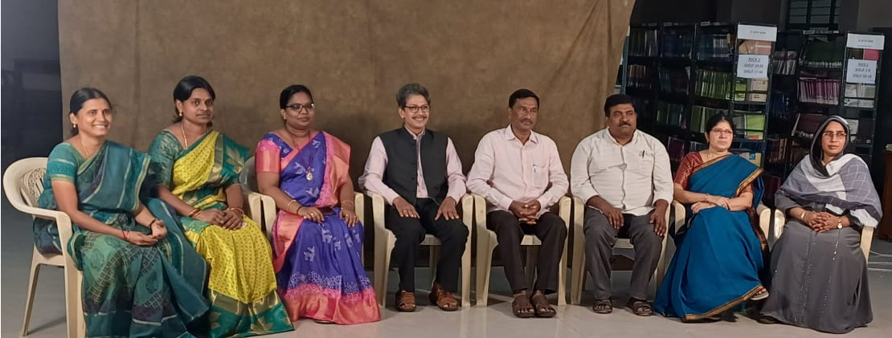
Examination Cell
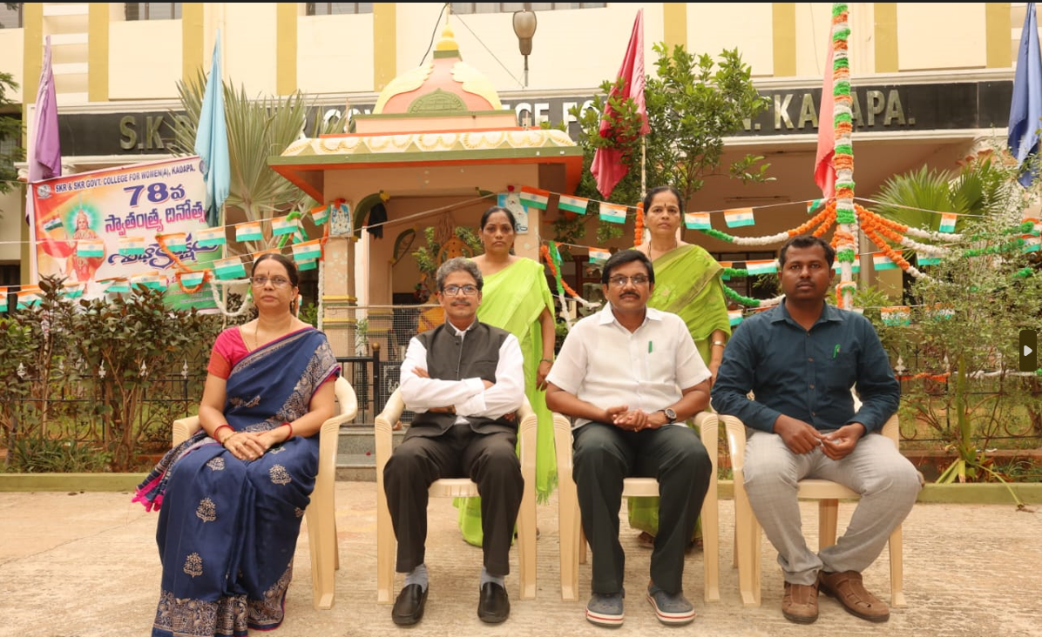
1.Haritha ., Det.of Computer Science(Member)
2. Dr.Saleem Bash., Principal (COE)
3.Dr.Subbramanum., Dept. Of Botany(Member)
4.Raghavendra.,Dept. Of Statistics (Asst.COE)
5.Raje Attende
6.Gori., Junior Assistant

Hostel Committee
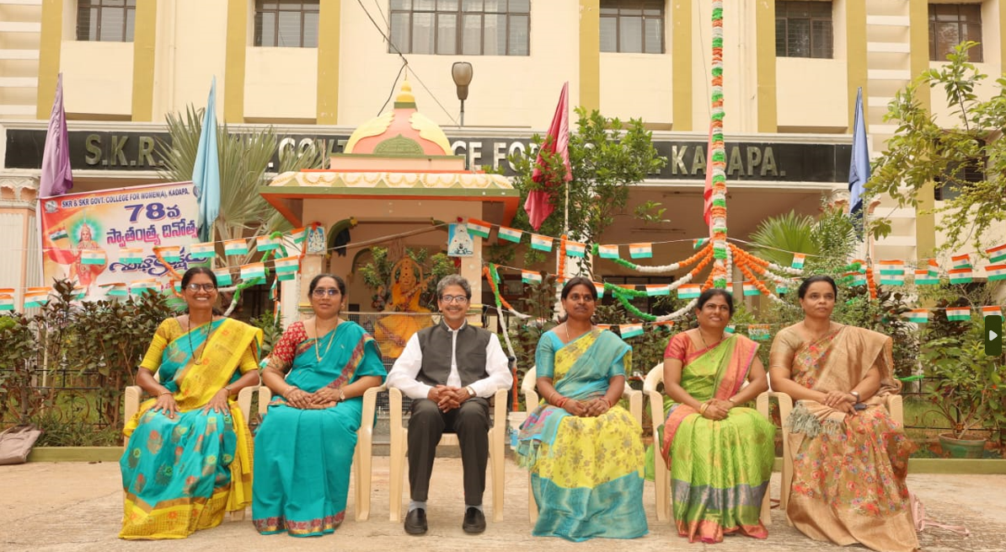
1.Dr.G.Vijaya Lakshmi., Member
2.Dr.Shazeeya Begum., Member
3.Dr.V.Saleem Basha., Principal Warden
4. Dr.Sawroopa., Deputy Warden
5.Anuradha., Member 6.Rizwana., Member
Alumni Associations Members:
President | Dr.V.Saleem Basha, Principal
Convener & Treasurer | Smt.V.Hama Kumari., Lecturer in Chemistry
Vice President | Dr.K.Shalini ., Lecturer in Mathematics
General Secretary | P.Laveena., Lecturer inBio- Chemistry
Joint Secretary | Smt.S.Siva Gowri ., Lecturer in Bio- technology
Executive Member | Dr.P.Sachi Devi., Assistant Professor
Executive Member | Smt.V.Aruna., Lecturer in Commerce
Executive Member | Smt.D.Subhanjali., Lecturer in Computer Science
Executive Member | Smt.K.Ramya Smitha., Lecturer in Computer Science

A Legacy of Excellence & Women Empowerment Since 1973
Genesis of the Institution
SKR & SKR Government College for Women (Autonomous), Kadapa was established in 1973 under the visionary leadership of Major Nadeemulla, the then Principal of Government College for Men (A), Kadapa.
Deeply concerned about the hardships faced by girl students traveling long distances for higher education, he took a historic initiative to establish a separate institution dedicated to women’s education.
His efforts were strongly supported by late Smt. Koti Reddy Ramasubbamma Garu, whose generous financial contribution and influence with the government made this noble dream a reality. In recognition of her support, the college was named SKR & SKR Government College for Women.
Humble Beginnings
The college initially functioned in a century-old Old Court Building located in the heart of Kadapa. Due to limited infrastructure, classes were often conducted under the shade of trees.
Despite these challenges, the institution stood strong with determination and commitment to educating women.
A dedicated committee of eminent personalities like:
Mrs. Rajalakshmi Nagarajan
Sri K. Bhujanga Rao
Sri J.C. Subbaiah
Sri P.V.N. Murthy
Dr. M. Krishna Murthy Rao
played a significant role in shaping the institution.
Academic Growth & Expansion
The college began with:
B.A. (HEP) – History, Economics, Political Science
B.Sc. (BZC) – Botany, Zoology, Chemistry
Later, B.Com. and several other programs were introduced.
Today, the college proudly offers:
✔ 14 Undergraduate Programs
✔ 2 Postgraduate Programs
✔ Conventional & Self-Finance Courses
Autonomy & Accreditation
Successfully completed Two NAAC Cycles
Preparing for Third Cycle Accreditation
Achieved Autonomous Status (2017–2026)
This autonomy has enabled the college to adopt innovative academic practices and modern curriculum design.
Innovative Teaching & Learning
The institution emphasizes student-centric education through:
Blended Learning (Online + Offline), Interactive Classroom Seminars, Field Projects & Study Tours, Guest Lectures by Eminent Scholars, Science Exhibitions & Cultural Programs.
The focus is on building skills, confidence, and global competencies among students.
Holistic Development Activities
The college ensures overall development through:
JKC (Jawahar Knowledge Centre) Training
NSS & NCC Activities
Red Ribbon Club (RRC)
Sports & Games
National Festivals & Cultural Events
The institution is widely appreciated for its discipline and transparent examination system.
Golden Journey: 50 Years of Excellence
Over five decades, the college has transformed into a vibrant centre of learning, achieving:
✔ Academic Excellence
✔ Increased Student Success Rates
✔ Strong Alumni Network
✔ Recognition for Quality Education
The college continues to inspire generations of women to achieve their dreams.
Proud Alumni
Our alumni have excelled in diverse fields:
Prof. P. Indira – S.K. University
Prof. Y. Prameela – Kakatiya University
V. Sreekumari – SBI Manager
Dr. P. Subba Lakshmamma – Retd. Principal
Dr. Vijaya Bharathi – Assistant Professor
M. Santha – Advocate/Notary
Dr. P. Sachi Devi – Zoology Department
Dr. J. Venkata Lakshmi – Principal
Infrastructure & Development
Key contributions include:
- Permanent Buildings Development
Well-Stocked Library
Hostel Facilities for Rural Students
Water Tank Construction
Hostel Dining Hall
- Seminar Hall
Special contributions by:
- Sri K. Jayabharata Reddy
- Late Sri Y.S. Raja Reddy
- Sri Natupalli Subba Reddy
- Modern Initiatives
- Establishment of Computer Lab & Courses
Introduction of Market-Oriented Programs (TTM) in 2017Continuous focus on digital learning and skill development
Department of Urdu – A Special Milestone under the leadership of Dr. Shazeeya Begum:
✔ B.A Urdu Medium (2013)
✔ B.A Urdu with Political Science (2021–22)
✔ B.A Special Urdu Major (2023–24)
This initiative has significantly empowered Urdu medium girl students in the region.
Extension & Social Responsibility
NSS Activities
2 Units with 500 Volunteers
Tree Plantation
Blood Donation Camps ,Village Adoption ,Clean & Green Programs,NCC Unit.200 CadetsLeadership & Discipline Training Active participation in national-level activities
Student Strength
The college currently has nearly 2000 students, reflecting its growing popularity and trust among the community.
Vision for the Future
With a strong legacy and progressive outlook, the college aims to:
✨ Promote Quality & Inclusive Education
✨ Strengthen Skill-Based Learning
✨ Empower Women for Global Challenges
✨ Expand Academic and Research Opportunities
Conclusion
SKR & SKR Government College for Women (A), Kadapa stands as a beacon of hope, empowerment, and excellence.From humble beginnings to a prestigious institution, it continues to shape the future of young women with knowledge, confidence, and values.
Donors of the College
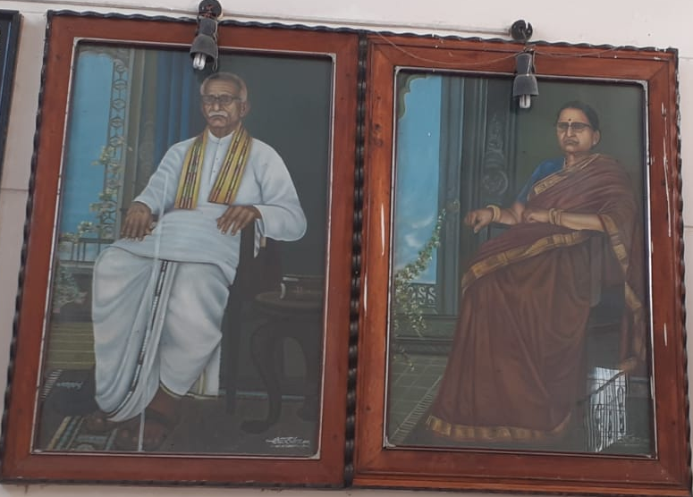
Sri .Koti Reddy Garu Smt.Koti Reddy Ramasubbamma Garu

The Cart of the course started from 1973 to 2025-26:
Programme Code | Programme Name | Year of introduction (Date)
0101 | B.A (History, Economics, Political Science) TM | 1973
0102 | B.A (History, Economics, Political Science) TM | 1973
0103 | BA (History, Economics, Computer Applications) EM | 2009
0104 | BA(History, Advance Urdu, Computer Applications) UM | 2013
0105 | BA(History, Advanced English, Tourism &Travel management) EM | 2017
0117 | B.A(History, Spl. Urdu, Political Science) UM | 2021
0206 | B.Com (General Commerce) TM | 1977
0218 | B.Com (General Commerce) EM | 2021
0207 | B.Com (Commerce ,Computer Applications) EM | 2009
0308 | B.Sc (Mathematics, Physics, Chemistry) EM | 2015
0309 | B.Sc(Botany, Zoology, Chemistry) TM | 1973
0310 | B.Sc(Botany, Zoology, Chemistry) EM | 2015
0311 | B.Sc(Mathematics, Physics ,Computer Science) EM | 1999
0312 | B.Sc (Mathematics, Electronics, Computer Science) EM | 2015
0313 | B.Sc(Mathematics, Physics ,Computer Science)EM | 1999
0314 | B.Sc(Biotechnology, Zoology, Chemistry) EM | 2003
0315 | B.Sc (Bio Chemistry ,Micro Biology, Chemistry) EM | 1998
0316 | B.Sc (Botany, Chemistry, Horticulture) EM | 2020
SM0101 | B.A. Honours ( Special English) | 2023
SM0102 | B.A. Honours ( Special Urdu) | 2023
SM0103 | B.A. Honours ( Economics) | 2023
SM0104 | B.A. Honours ( History) | 2023
SM0105 | B.A. Honours ( Political Science) | 2023
SM0211 | B.Com Honours(General) | 2023
SM0212 | B.Com Honours((Computer Applications) | 2023
SM0321 | B.Sc Honours (Botany) | 2023
SM0322 | B.Sc Honours (Chemistry) | 2023
SM0323 | B.Sc Honours (Computer Science) | 2023
SM0324 | B.Sc Honours (Mathematics) | 2023
SM0325 | B.Sc Honours (Organic Chemistry) | 2023
SM0326 | B.Sc Honours (Physics) | 2023
SM0327 | B.Sc Honours (Zoology) | 2023
PG | MA(English) | 2012
 | Msc(Zoology) | 2020

Item No. 12: Result Analysis:
Result Analysis of I to VI semesters in autonomous for the academic year 2024- 24. The College got creditable Pass Percentage in the semester end examinations in all the UG programmes. Detailed group wise analysis.
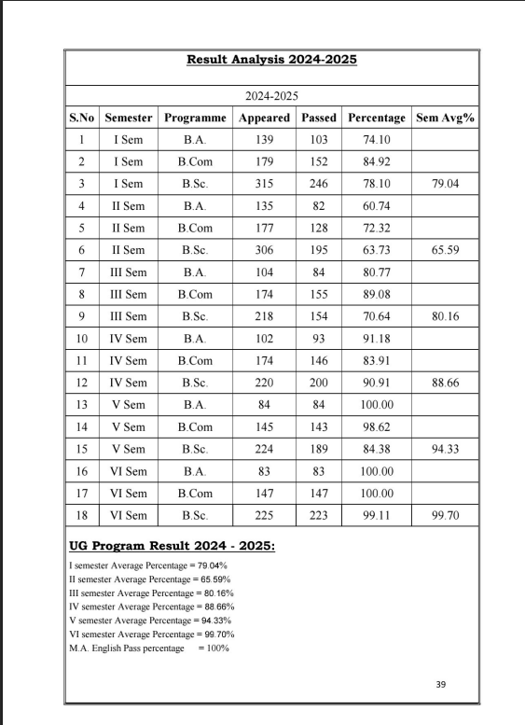

Item No. 15: Approval of new UG Programmes:
In the Academic year 2024-25, the following Single Major degree programme, aresanctioned through theProceedings of the Commissioner of Collegiate Education., AP,Mangalagiri. Proc. No 76/O.P-II/2023-1, dated 04-07-2023.
UGPROGRAMMES:
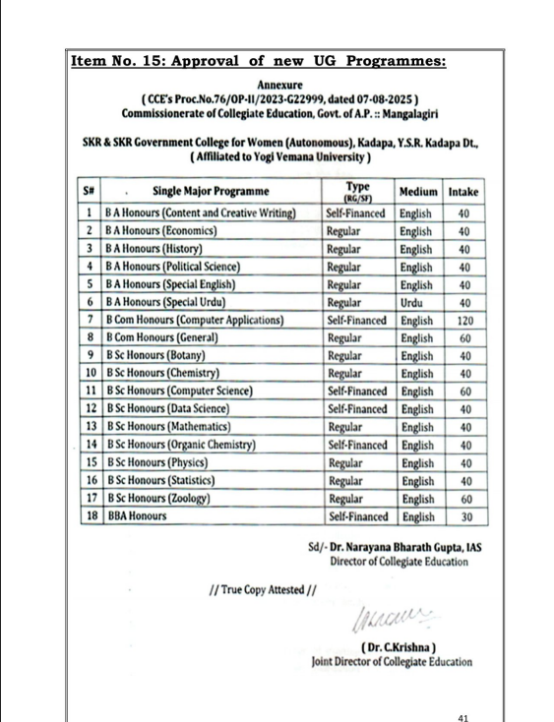

Online admissions are conducted for UG programs through OAMDC 2024-2025, APSCHE. The admissions in PG courses are done through APPGSET the counseling conducted by YVU.
Item No. 17: Extra and Co-Curricular Activities:
All the students have equal opportunity to utilize extracurricular activities in the institute by enrolling themselves in NSS / NCC / Sports & games / Cultural Activities or any other service organization in the College.
The Academic council emphasized the importance of physical education in the college for all round development of young women of this institution by involving them in games and sports. The Department of Physical Education is striving hard in keeping women physically fit and to participate in all tournaments. In 2025-2026, 17 college students represented YVU in all India south zone inter university tournaments. The Department of Physical Education follows the below given criteria for the benefit of students of the institute.
- Identifying, selecting players and organizing intensive coaching camps for the students in all disciplines.
- Maintenance of playfields from available funds.
- Conducting intramural competitions in sports and games
- Participation in Extramural competitions in sports and games conducted by University and CCE.
- To Award prizes to the place secured students
- To enhance student enrolment in participation of sports and games and to keep them healthy.

Co-Curricular Activities:

In order to develop knowledge and skills in students the college conducts other Curricular Activities viz. Essay writing, Elocution, Group Discussion, Quiz Programme, Seminars in each department. These will improve Communication Skills, enhance subject knowledge, current affairs and competitive spirit to compete with other students in competitive exams.
College Specialties:
- The only first Government College for Women in Kadapa district with a history of more than 50 Years in the Heart of the city.
- A unique institute with 24 experienced faculty members with Ph.D.
- C.C.An educational institution with a specious camp under the supervision of cameras.’ edx ‘online certificate courses approved by APSHE.
- Teaching of science curriculum in 3Dview through AR/VR studios in classrooms for the first time in Rayalseema colleges.
- The only Government women’s college, NAAC recognized and autonomous.
- Women’s college imparting quality education in modern manner through ICT.
- Fully equipped Labs and Auditorium, Botanical Garden, Solar system Renewable Energy.
- Job training through JKC, we have very year job drive/campus Drive through Placement cell.
- Job, Career awareness programs through Career Guidance Cell.
- The College prepare online e-content through LMS Portal.
- Teaching Learning process through AI & Digital & Virtual Class Rooms.
- 25,000 above books, influent having Digital Library & “Book Hundi” initiative .
- Social services through NCC,NSS and Red Ribbon Club & Sports, Games and Cultural Activities .
- We provided Hostel/Canteen/Gym/Bus Pass/Ro water Plant/Xerox centre facility.
- Through Women Empowerment Cell we get Awareness Programme on Gender equality.
- College providing Scholarships to deserving students.
- Community Service Projects/Apprenticeships/Short Term and Long term Internship.
Innovation in Teaching and Learning:
In tune with the changing scenario in learning process across the globe it is necessary to utilize communication technology for teaching and learning to the optimum. All the lecturers are guided and advised to enrol the students for MOOCS online courses. Teaching faculty is drawn their attention to utilize the available two Virtual Class Rooms and Three Digital Class Rooms for effective teaching and learning for better outcome. They are also directed to take online and offline classes and to use appropriate teaching methods like problem solving based learning, interactive learning, writing for learning, guided learning and peer learning, Pedagogical Methods where ever necessary to grass the original concept by the students. All the teaching faculty are directed to prepare e- content in different topics of their subjects by the proceedings of the CCE for the benefit of the students. According to NEP 2020 and as per the guidelines of the APSCHE Lr.No. APSCHE/AC/CBCS-2019-20/Review/22m dated on 27-06-2022 10 month internship is mandatory for all UG Programs in 3 phases – 1st phase of internship is a CSP (Community Service Project), after the end of 2nd semester examinations; 2nd phase of Apprenticeship/Internship/Industry Connectivity is after the end of 4th semester examinations and the 3rd final phase of Apprenticeship/Internship/On the Job Training is semester 5/6 is mandatory.
It is submitted to Academic Council for discussion and approval. Extra and Co-Curricular Activities:
All the students have equal opportunity to utilize extracurricular activities in the institute by enrolling themselves in NSS / NCC / Sports & games / Cultural Activities or any other service organization in the College.
The Academic council emphasized the importance of physical education in the college for all round development of young women of this institution by involving them in games and sports. The Department of Physical Education is striving hard in keeping women physically fit and to participate in all tournaments. The Department of Physical Education follows the below given criteria for the benefit of students of the institute.
- Identifying, selecting players and organizing intensive coaching camps for the students in all disciplines.
- Maintenance of playfields from available funds.
- Conducting intramural competitions in sports and games
- Participation in Extramural competitions in sports and games conducted by University and CCE.
- To Award prizes to the place secured students
- To enhance student enrolment in participation of sports and games and to keep them healthy.

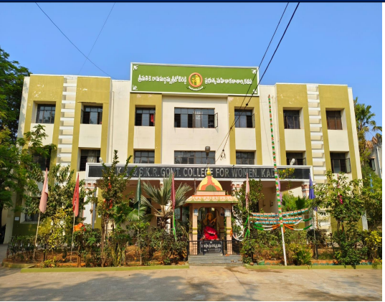

Certificate Courses offered by institution for the academic year 2025-26
Academic year 2025-2026 certificates courses planned all the Departments
Name of the Dept | Name of the certificates courses |  | No.of student join | No. of students completed
English | Interview Skills | 20-08-25 to 29-09-25 | 20 | 20
Telugu | Telugu literaturary Appreciation | 1-12-2025 to 30-12-2025 | 25 | 25
Urdu | Urdu Mazmoon Nigari | 1.12.2025 to 30.12.2025 | 20 | 20
Political science | Indian Constitution | 23.11.2025 To 22.12.2025 | 30 | 30
Economics | Photography |  | 30 | 30
History | 1. Historical tourism 2.heritage management | 10-03-2026 to 28-04-2026 | 26
Zoology | Ornamental fish Farming | 1.8.2025 to 15.09.2025 | 34 | 34
Chemistry | Introduction to Molecular Thermodynamics | 20-01-2026 to 20-02-2026 | 20 | 20
Computer science | Computer Literacy: MS-Excel | 21-01=2026 to 21-02=2026 | 20 | 20
Computer science | Fundamentals of Photoshop | 21-01=2026 to 21-02=2026 | 26 | 26
Computer science | Computer Literacy: MS-Word | 21-01=2026 to 21-02=2026 | 22 | 22
Computer science | G - Suite | 23-02-2026 to 23-03-2026 | 20 | 20
Computer science | Fundamentals of MS Access | 23-02-2026 to 23-03-2026 | 20 | 20
Computer science | Cloud Computing basics | 23-02-2026 to 23-03-2026 | 20 | 20
Computer science | WEKA - AI Desktop Platform | 23-02-2026 to 23-03-2026 | 20 | 20
Maths | Verbal reasoning | 3-9-25 To 22-9-25 | 30 | 20
Mathematics | Competitive skills | 2-2-2026 To 24-3 -2026 | 20 | 20
Mathematics | Logical reasoning | 24-2-2026 To 6-4-2026 | 20 | 20
Mathematics | Critical thinking | 24-2-2026 To 6-4-2026 | 20 | 20
Chemistry | Essentials of Biomolecules-I | 02-12-2025 to 02-01-2026 | 20 | 20
Chemistry | Fundamentals of Spectroscopy | 23.01.2026 to 23.02.2026 | 20 | 20
Chemistry | Essentials of Biomolecules-II | 20-01-2026 to 20-02-2026 | 20 | 20
Chemistry | Bioinorganic Chemistry | 23.01.2026 to 23.02.2026 | 20 | 20

Online admissions are conducted for UG programs through OAMDC 2024-2025, APSCHE. The admissions in PG courses are done through APPGSET the counselling conducted by YVU.
Extra and Co-Curricular Activities:
All the students have equal opportunity to utilize extracurricular activities in the institute by enrolling themselves in NSS / NCC / Sports & games / Cultural Activities or any other service organization in the College.
The Academic council emphasized the importance of physical education in the college for all round development of young women of this institution by involving them in games and sports. The Department of Physical Education is striving hard in keeping women physically fit and to participate in all tournaments. The Department of Physical Education follows the below given criteria for the benefit of students of the institute.
- Identifying, selecting players and organizing intensive coaching camps for the students in all disciplines.
- Maintenance of playfields from available funds.
- Conducting intramural competitions in sports and games
- Participation in Extramural competitions in sports and games conducted by University and CCE.
- To Award prizes to the place secured students
- To enhance student enrolment in participation of sports and games and to keep them healthy.

Memorable Activities:

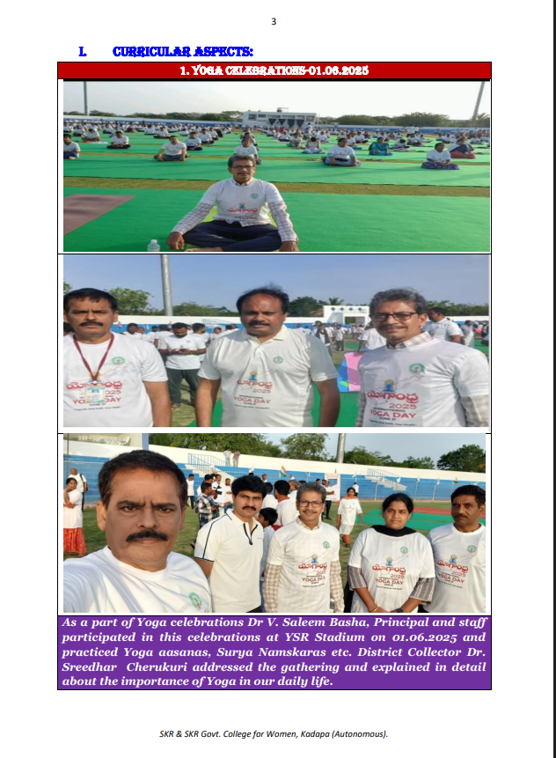
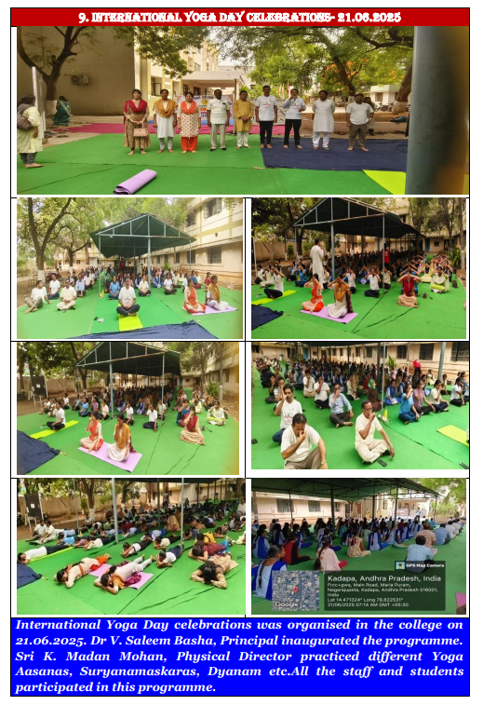
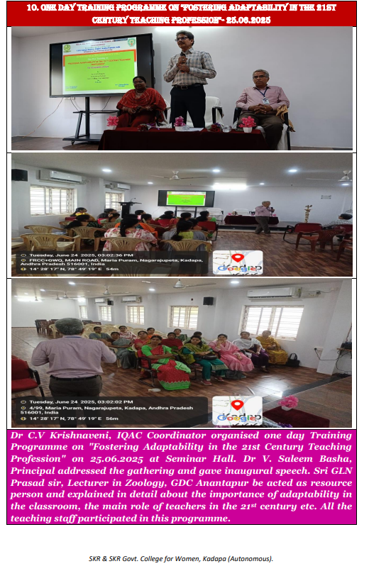

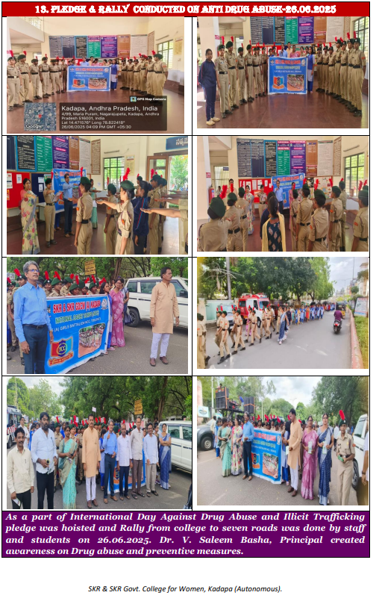
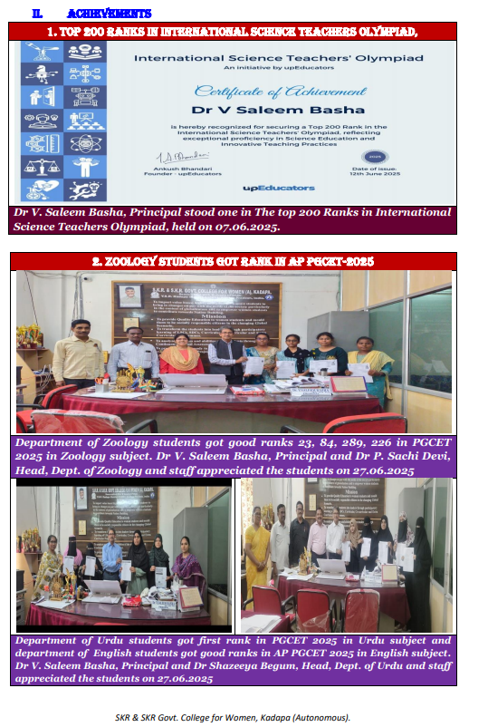

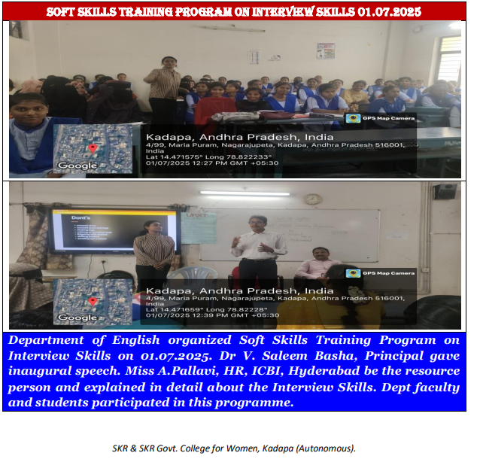

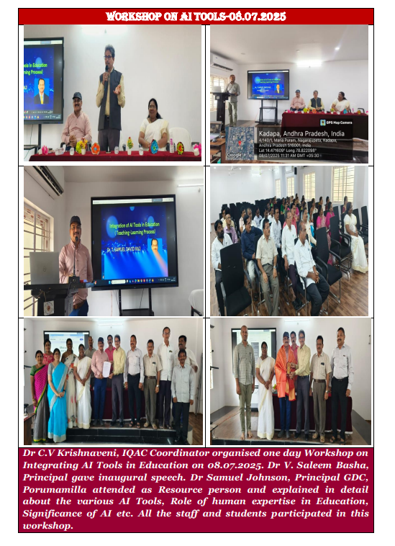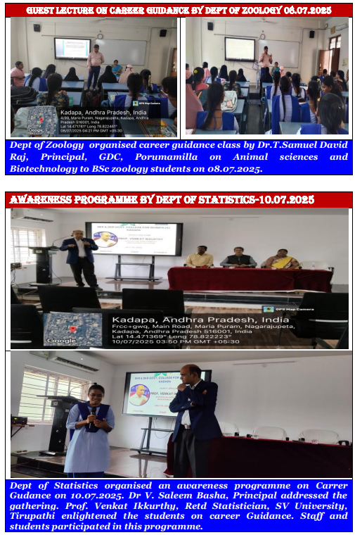

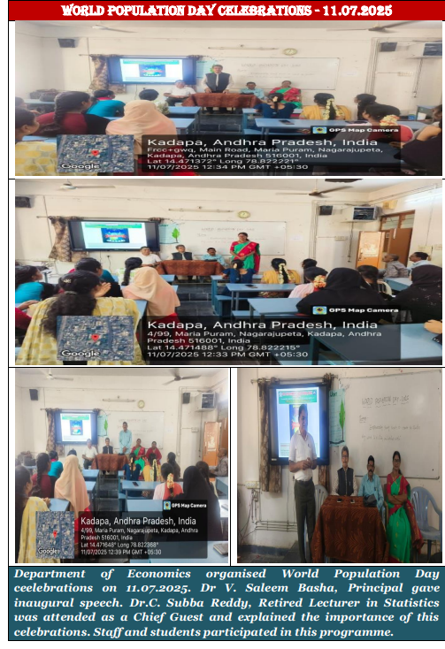

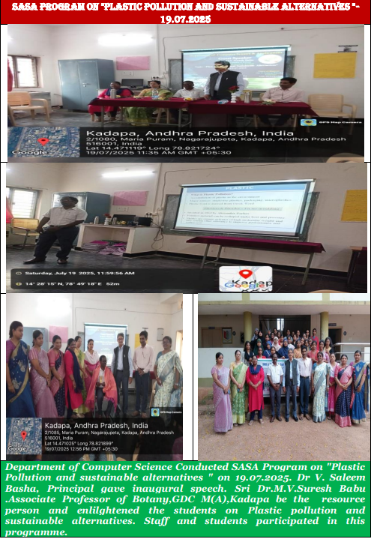

NCC :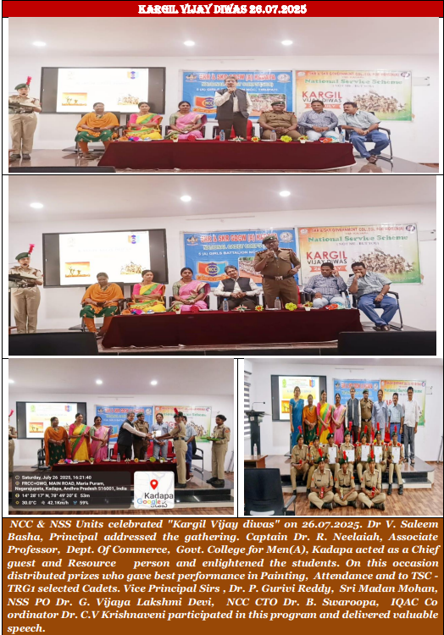
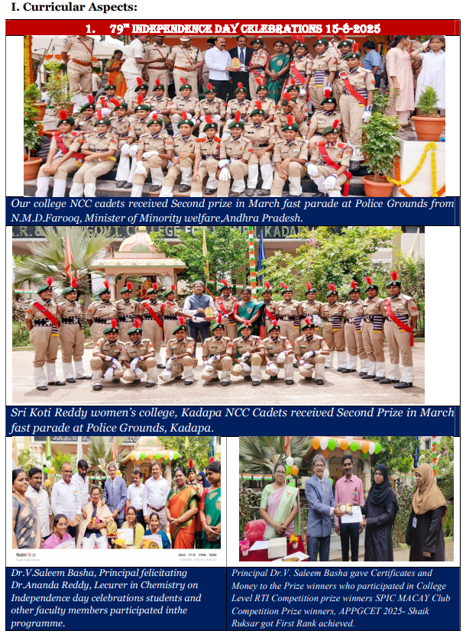
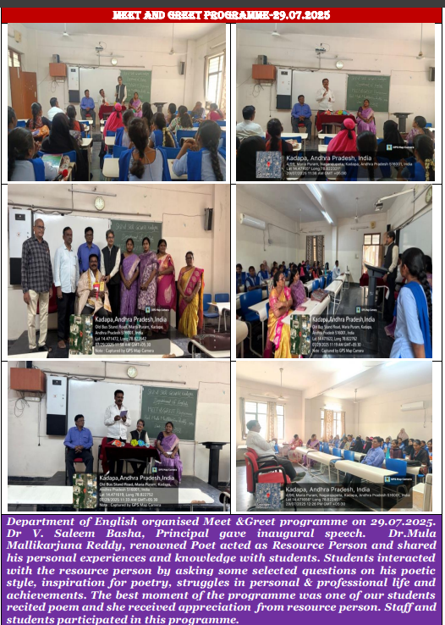
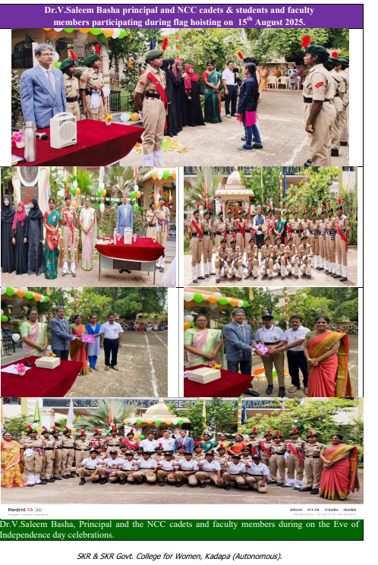
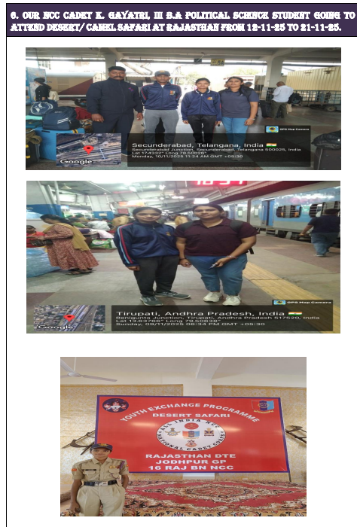
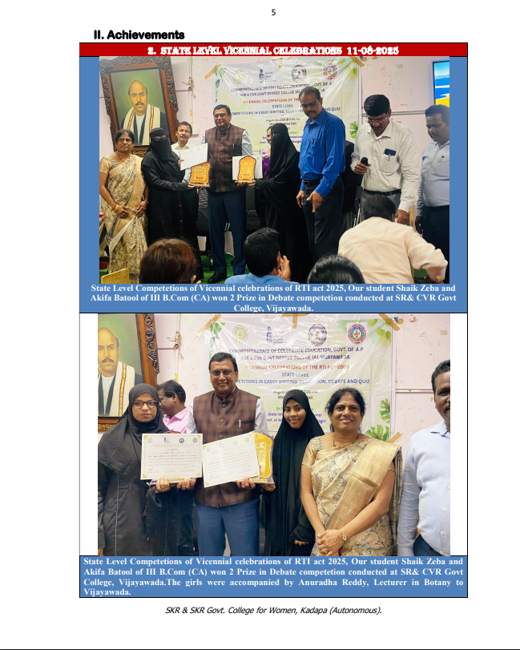

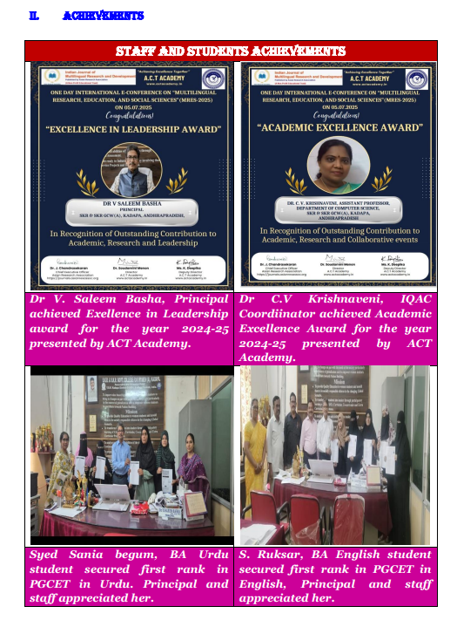

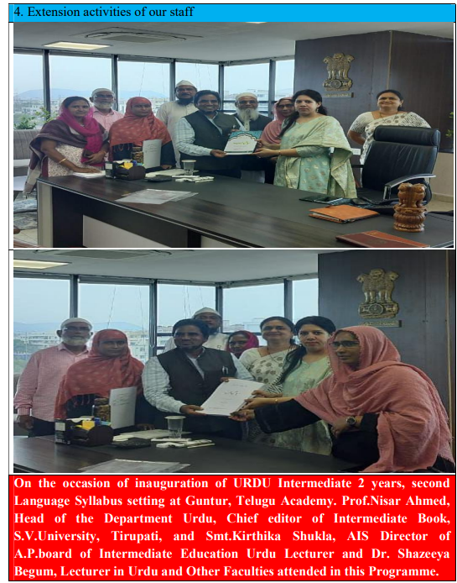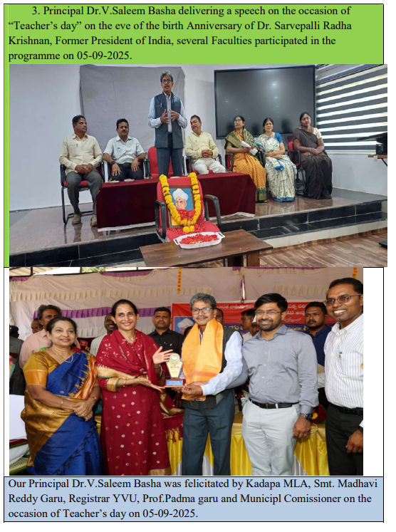

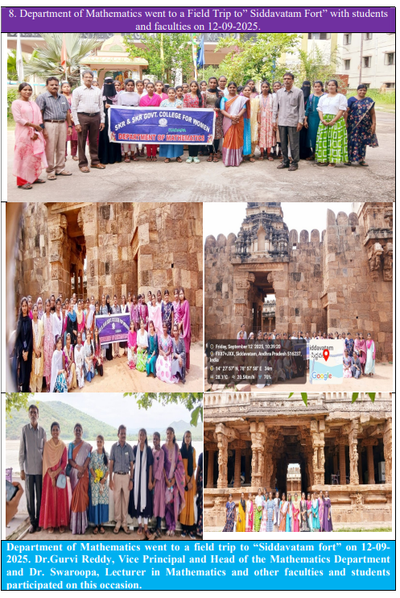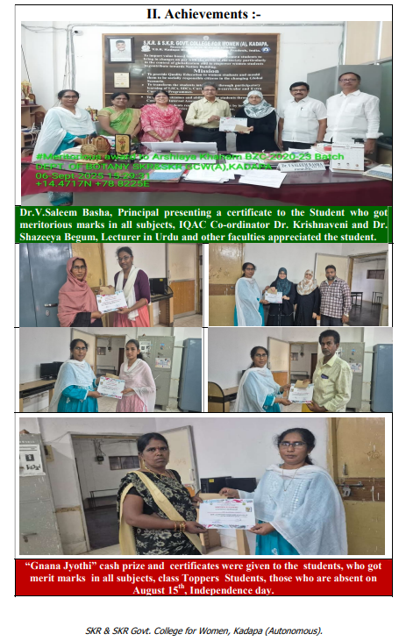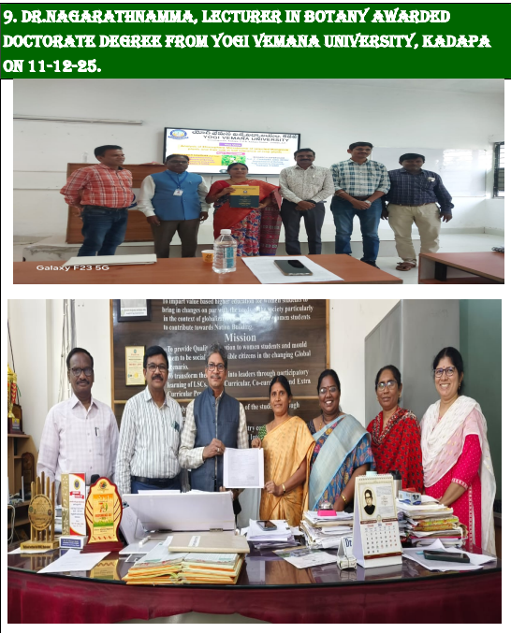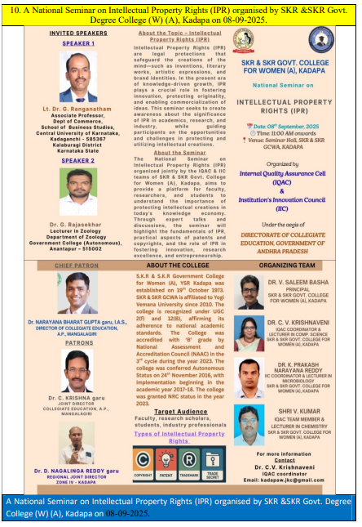
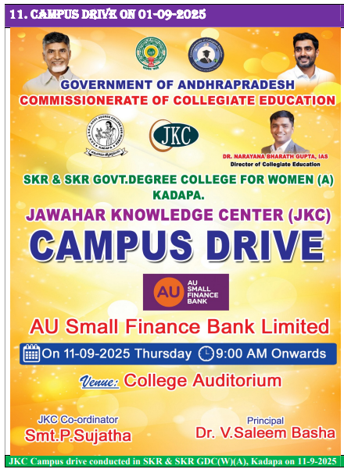
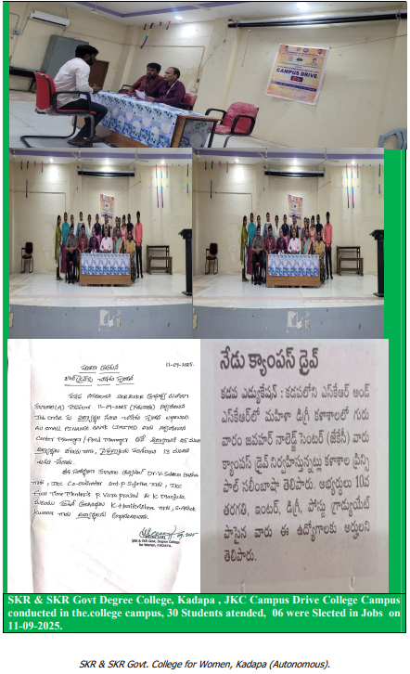
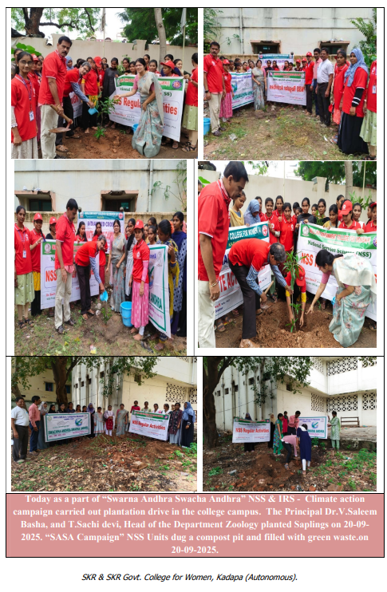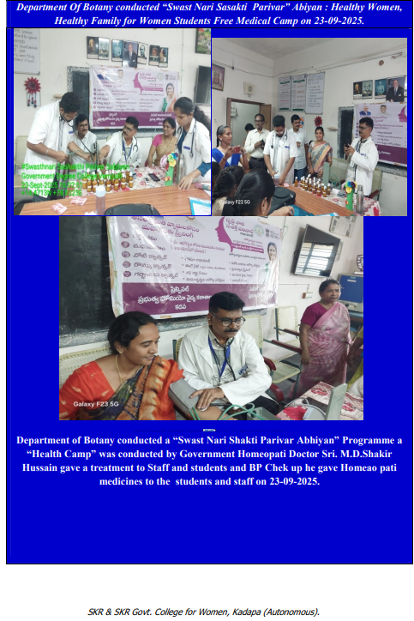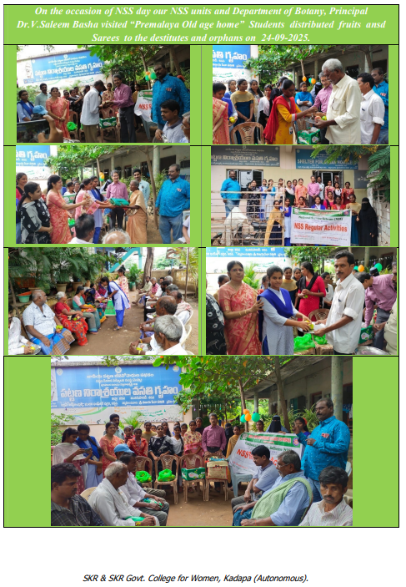

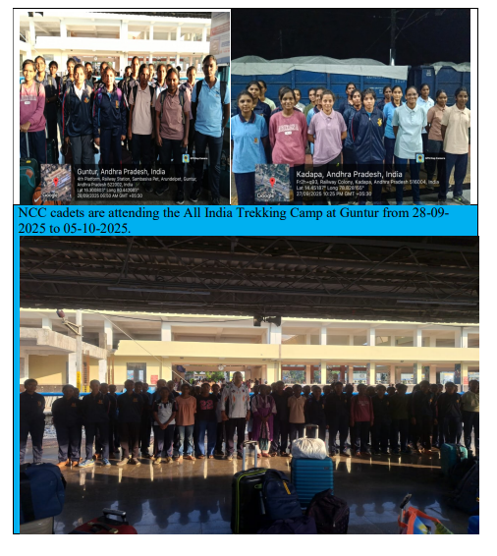
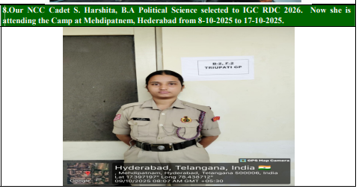
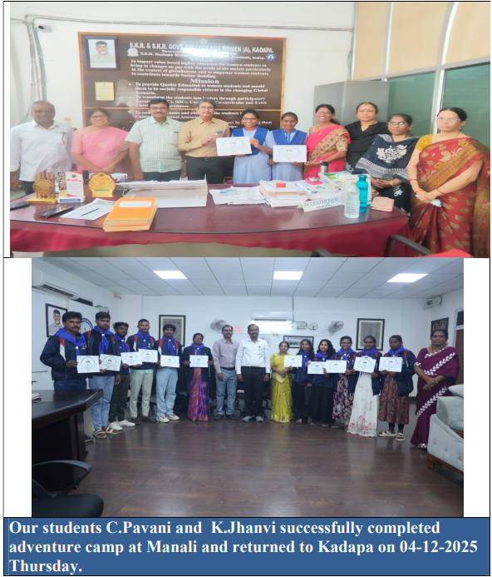
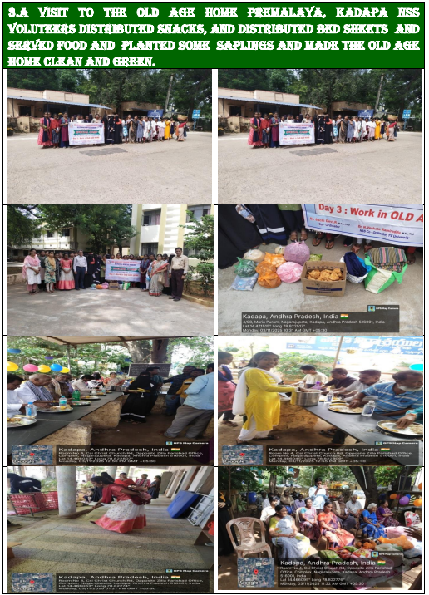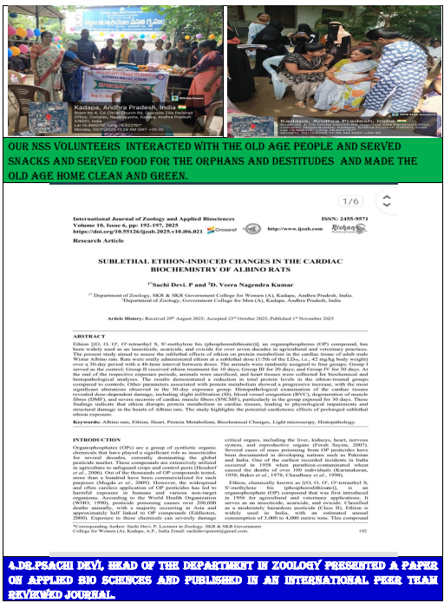
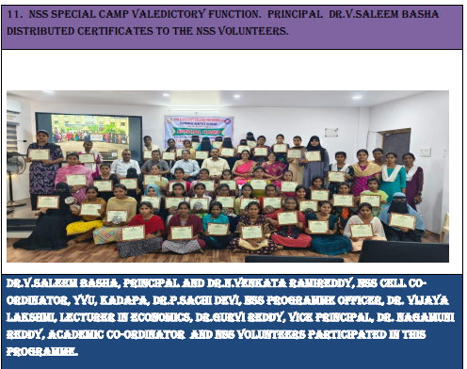
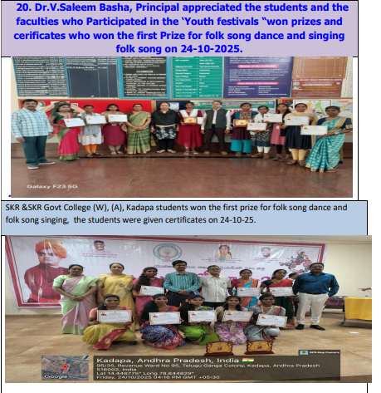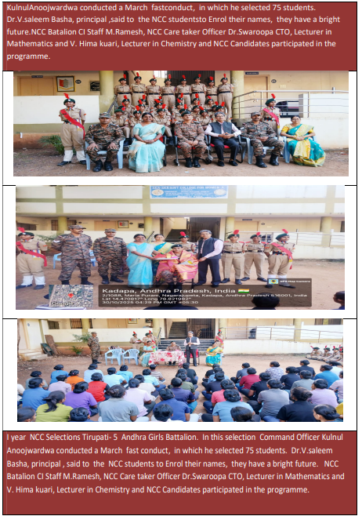
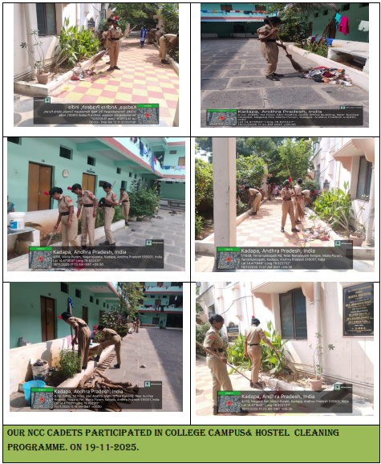
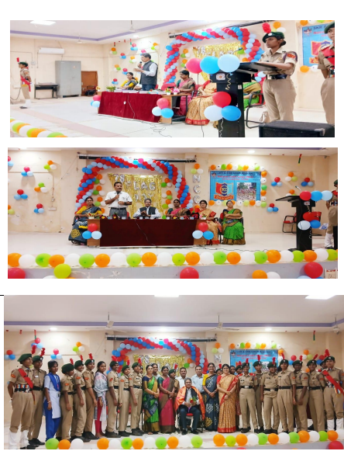
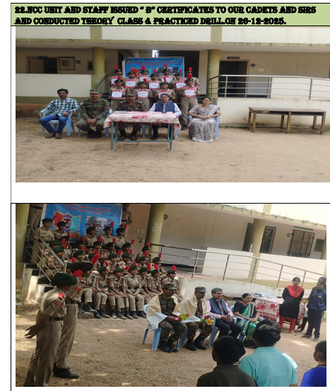
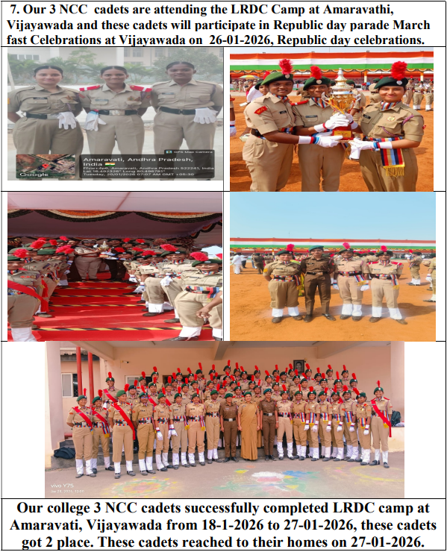
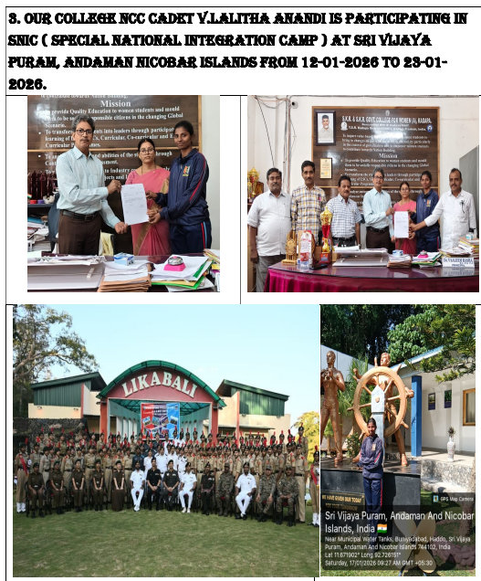
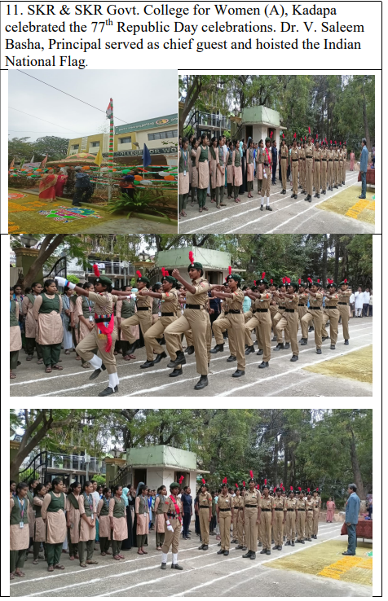
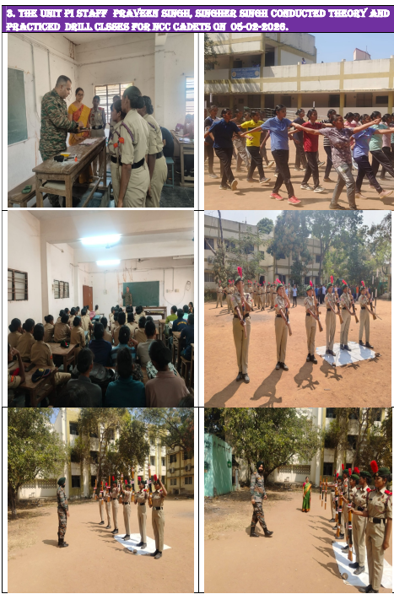
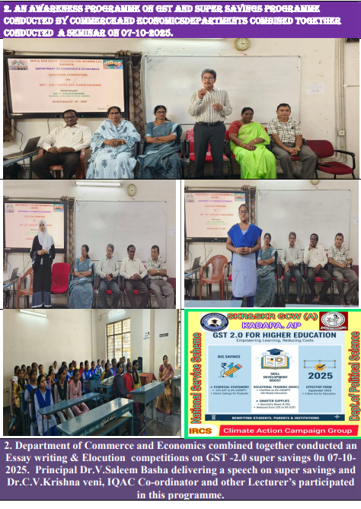
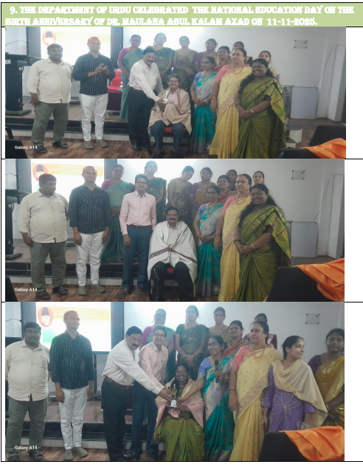

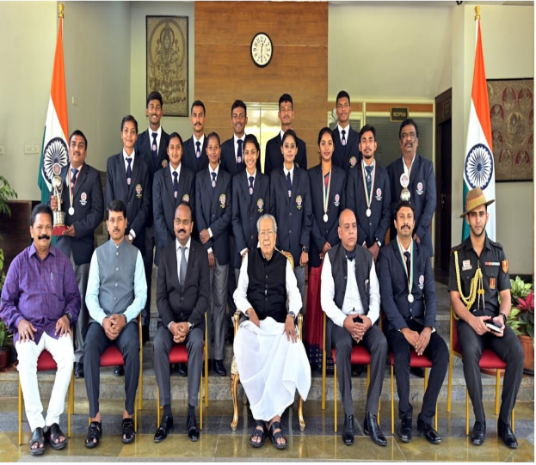

SKR & SKR GDC Women (A), Kadapa NSS Unite participated in Republic Pared at New Delhi.

SKR & SKR GDC Women (A),Kadapa NSS Unite with A.P Honorable Chief Minister Y.S.R Jagan Mohan Reddy .

SKR & SKR GDC Women (A),Kadapa NSS Unite with A.P Honor’ble Commissioner of Collegiate Education Dr. Pola Bhasker Sir

NCC Activities:
rSports and Games:
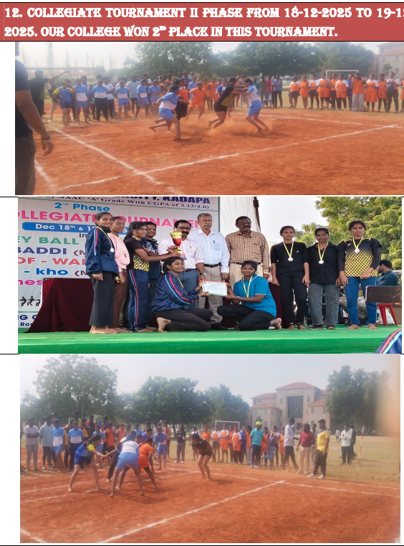
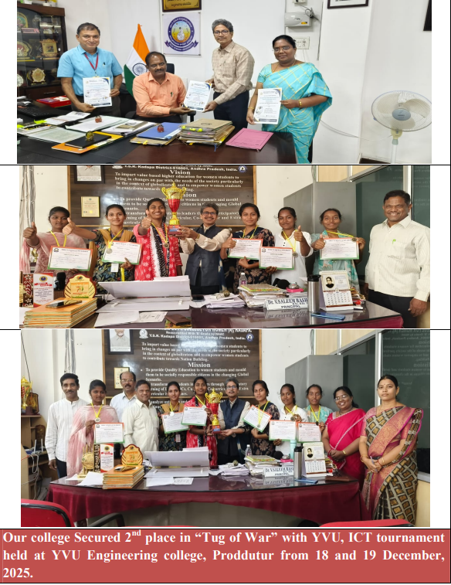

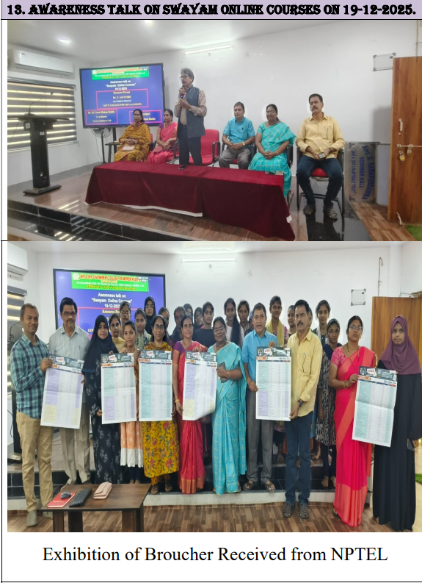
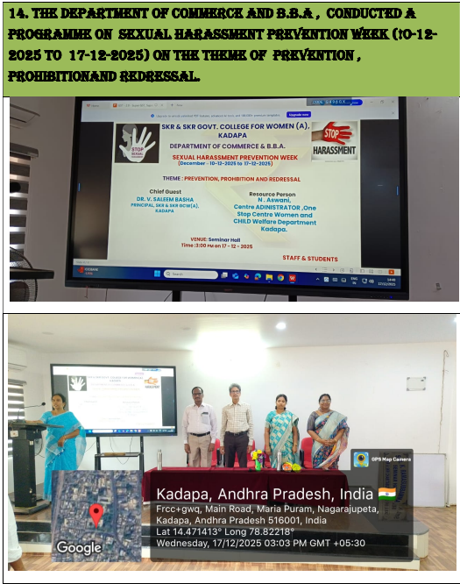
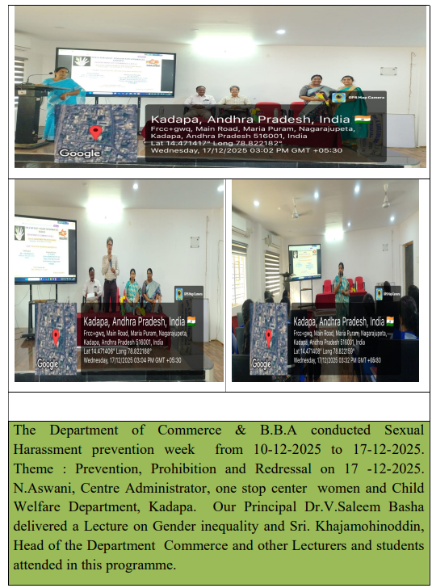
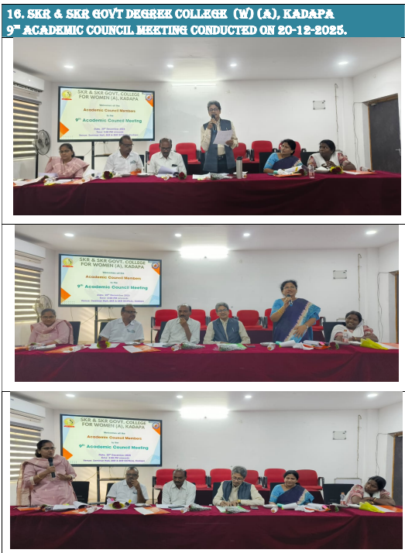
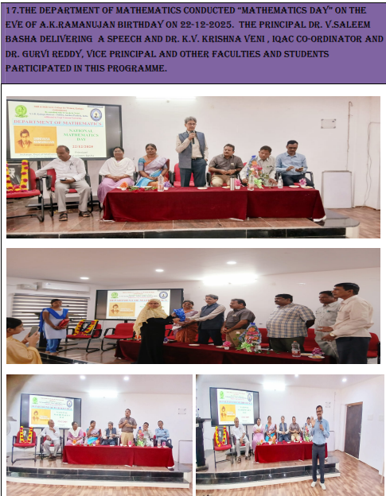
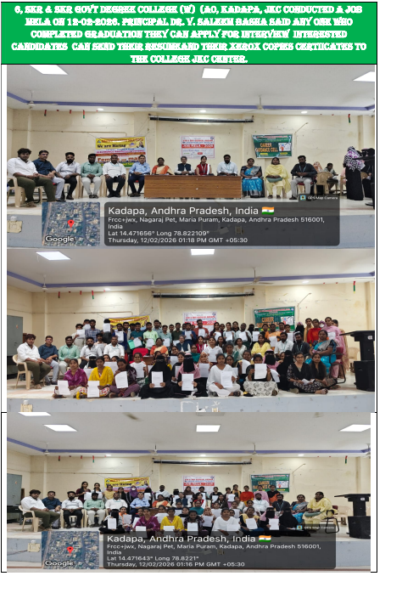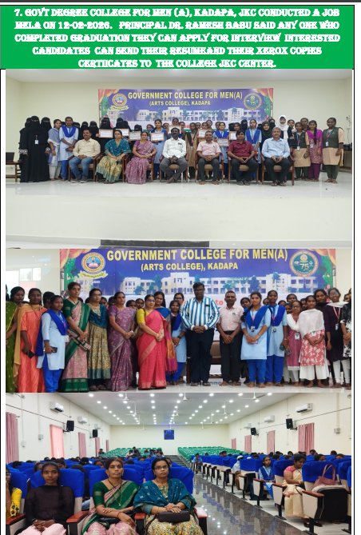
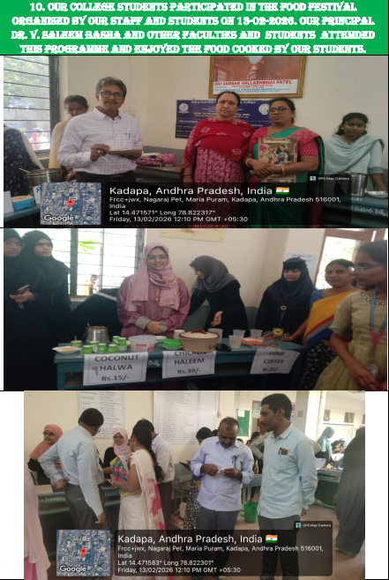
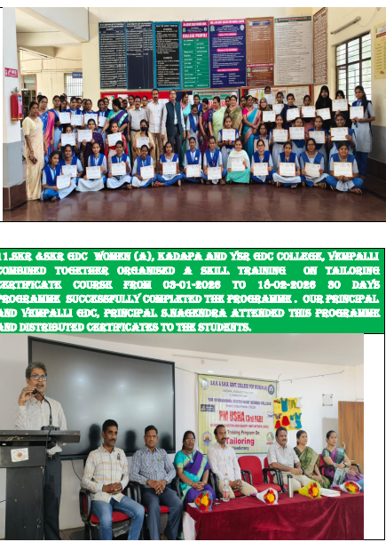
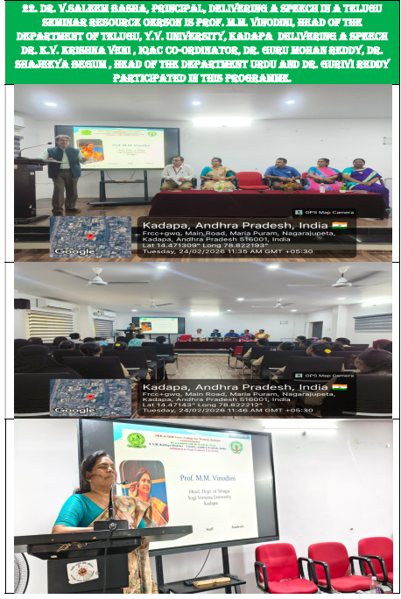
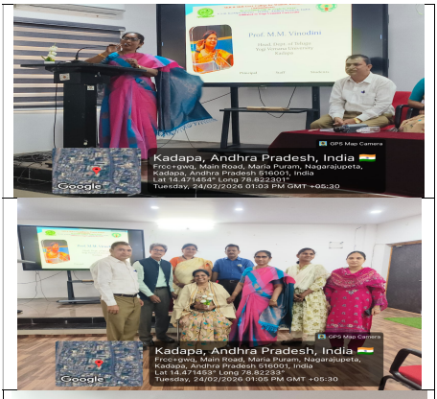
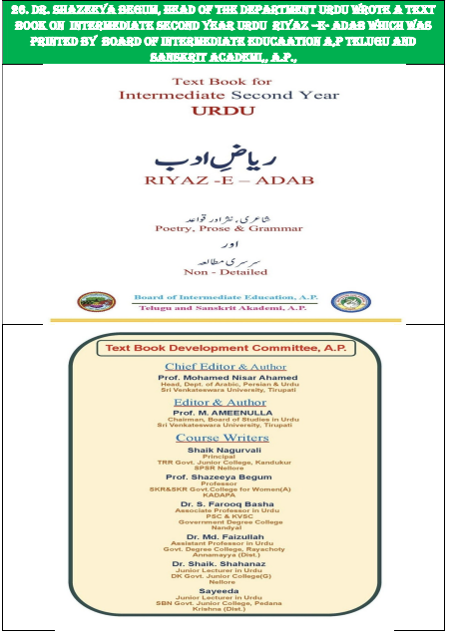

Iam safe....

Iam safe....  పదే పదే  ఇంకా నిద్ర లేవవేంటి అని అడిగేవారు లేరు...  ఇంకా ఎంతసేపు వంట అని దెప్పేవారు లేరు  ఎంటా రెఢీ అవ్వడం అని చూసేవారు  ఇలానా ఇల్లు సర్దేది అని ప్రశ్నించేవారు లేరు..  Iam safe..  ప్రయాణం చేయాలంటే పక్కనే ఉండి మాట్లాడే వారు  ఎంత దూరం అయినా పర్లేదు తోడుంటా అనేవారు  తిన్నావా..  ఏదైనా తెప్పించనా  ఎక్కడున్నావు  ఇంకా రావేంటి  ఇవాలైనా నాకోసం సమయం కేటాయించరాదు అని బ్రతిమిలాడేవారు లేరు...  Iam safe...  ఏదైనా చెబితే వినవేంటి  అంత మొండితనం నీకేంటి  నీ నవ్వులకు  నీ మాటలకు అర్థాలు వేరని వెటకరించే వారూ లేరు | Iam safe...  ఏం రాస్తున్నవని  ఎందుకు రాయట్లేదని  బానిసత్వం కాదు బంధుత్వం కావాలని  గుక్కపట్టి ఏడ్వటాలే కాదు చేతులుపట్టుకుని సముదాయించేవారు లేరు..  Iam safe  అతిగా ప్రేమిస్తే  ఆ ప్రేమని తట్టుకొని నిలబడటానికి నాకు గుండెలేదని  అతిగా విరహిస్తే నాకు కన్నీళ్లు లేవని లెక్కలేసే మనిషి లేరు  Iam safe...  ఇంకా చాలా లేవు..  అవన్నీ లేవని  చెప్పే సమయాలకు కూడా నాతో పనిలేదు  ఈ కొన్ని లేవని చెబుతుంటే గుండె బరువెక్కుతుంది  ఇంకాస్త కలిపి చెబితే ప్రాణం మిగులుతుందొ లేదో మరీ  Iam safe...  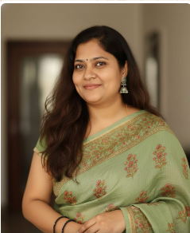  డాక్టర్ యం వి యన్ సుధారాణి  ఒప్పంద తెలుగు అధ్యాపకులు  ఎస్ కే ఆర్ & ఎస్ కే ఆర్ ప్రభుత్వ మహిళా డిగ్రీ కళాశాల (స్వయం ప్రతిపత్తి)  కడప

అలమటిస్తున్న #తెలుగుభాష ...
అలమటిస్తున్న #తెలుగుభాష ...  ఆడపిల్ల పుడితే #అమవాస్య  అవని కూడా ఆడపిల్లే అని మరిచిన లోకం  తల్లిగా, కూతురిగా ,భార్యగా తన విలువని కొలవలేని ఈ లోకం  #తెలుగుతల్లిని,#తెలుగుభాషని ఎలా కీర్తిస్తుందిలే  #అమ్మా #నాన్న అన్న పిలుపు వినాలంటే ఎన్ని దశాబ్ధాల ముందుకు వెళ్ళాలో....  #మమ్మీ #డాడి అని ప్రాణం లేని #రోబో పిలుపులు ... అయినా యుగం కదా ఇది.. తప్పదు  ఏ భాషనైనా అసంపూర్తిగా వాడడం ఎంతవరకు సమంజసం ...  #మాతృభాషని ఎంత ఆప్యాయంగా చూసుకుంటారో పక్కరాష్ట్రాన్ని చూసైనా నేర్చుకోవాలి మన తెలుగు రాష్ట్రాలు ...  #మాండలికాన్ని మాట్లాడితే ఎంత సంతోషంగా ఉంటుంది ....  వేరే దేశానికి మనం వెళ్ళినపుడు మన భాష విలువని కనుగొంటాం ...  అందుకని అంతా దేశాలు వెళ్ళగలరా ...  సముద్రాలు దాటితేనే తెలుసుకోగలమా ...  ఎన్నో అక్షరాలను తెలుగు అక్షరమాలలో ఇప్పుడు తీసేశారు ....  మన శరీరంలో కొన్ని పనికిరాని అవయవాలని ఆపరేషన్ ద్వారా తీసేసినట్టు ...  పలకలేరని ..పనికిరావట్లేదని ...  కనీసం ఉన్నవాటినైనా బ్రతికించుకోవాల్సిన బాధ్యత మనదే ...  #క్ష గుణింతాన్ని పలకలేని | నేర్చుకుందాం అనుకునే వాళ్ళు ఎంతమంది ...  #భాషనునేర్చుకుందాం ...  నేర్పిద్దాం....  నేర్చుకునేలా చేద్దాం ...  చరిత్రలో ఉండడం కాదు మన భాష ...  ప్రతి చదువుకున్న,చదువుకోని మనిషిలో తప్పక ఉండేలా చూద్దాం...  #ప్రభుత్వానికి ఇది పెనుసవాలే ..  కాని అదే మనకు గొప్ప గౌరవం ....అంతర్జాతీయ  మాతృభాషదనోత్సవ  శుభాకాంక్షలతో ....  మహాత్ములున్నారు,ఉపాధ్యాయ వృత్తిలో ఉండి కూడా ...  అందరికి అన్ని వస్తాయా ..రావు .....  నాకు చాలా విషయాలు తెలియదు... ఇది నిజం  కనీసం ఉన్నవాటినైనా బ్రతికించుకోవాల్సిన బాధ్యత మనదే ...  #క్ష గుణింతాన్ని పలకలేని  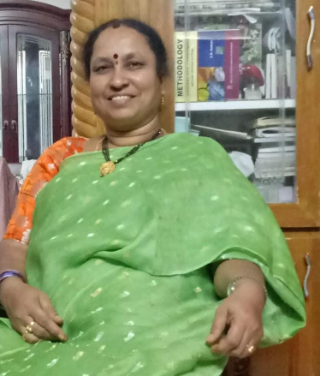  డాక్టర్ పి యం ఆర్ జయంతి  హిందీ అధ్యాపకులు  ఎస్ కే ఆర్ & ఎస్ కే ఆర్  మహిళా డిగ్రీ కళాశాల

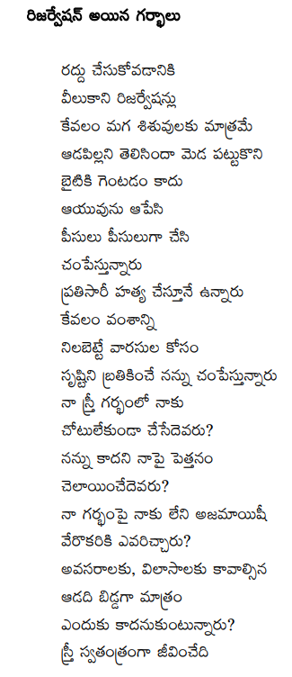 | 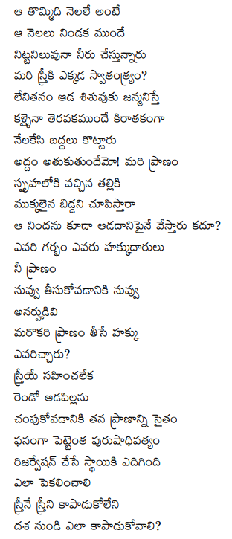
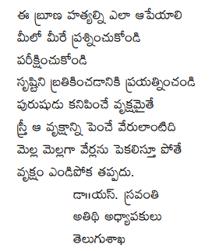 | 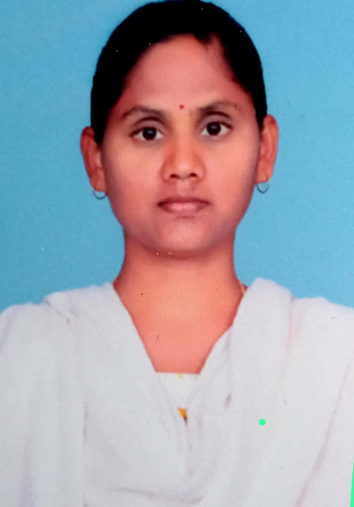

ఎక్కడ నేను  వెతుకుతున్నా నా కోసం నేను ఎక్కడున్నా నేను  అందరి కోసం అన్నీ చేస్తూ నాకోసం నేను ఏమీ చేయకుండా అజ్ఞాతంలో నేను ఎక్కడున్నా నేను  నా వాళ్ళ కోసం నేను  నా అన్న వాళ్ళ కోసం నేను నా మనుష్యుల మధ్య నేను మీ మనసులకు చేరువకాలేనంత దూరం నేను వెతుకుతున్నా నా కోసం నేను నా తల్లిదండ్రుల ప్రేమలో నేను నా తోబుట్టువుల రక్షణలో నేను  నా బంధుమిత్రుల నమ్మకంలో నేను  పెళ్లి పేరుతో తల్లిదండ్రుల బాధ్యత ముగిసింది  భర్త పేరుతో రక్షణ ముగిసింది పేదరికంతో బంధుమిత్రుల నమ్మకం ముగిసింది  ఎక్కడ నేను  ప్రేమ, బాధ్యత, రక్షణ నమ్మకం,.. వీటిలో ఎక్కడ నేను  నా రక్త మాంసాలతో నిన్ను రూపించుకొని  రెండుగా నా శరీరాన్ని చీల్చుకొని  చిరునవ్వుతో నిన్ను చూసుకున్న  లేత చిరు పుప్పొడి లాంటి నీ స్పర్శతో  నేను బాధ్యతగా మారిపోయా నీ రక్షణే నా కర్తవ్యం | నీ రూపమే నా అందం  నా ఊపిరి  నా నమ్మకం  నా వాస్తవం నువ్వు  నీ రెక్కలు విచ్చుకున్న వేగానికి నేను మాయం ఎక్కడ నేను  అక్షరంలో శిరాలాగా భూమిలో విత్తులాగా ప్రకృతిలో గాలిలాగా ఎన్నింటినో దాచుకున్న చిత్తుకాగితం లాగా సూర్యుడిని అంటుకున్న నిప్పు పుప్పొడి లాగా నేను అందరి ఆయువులో నేను మరో ఉదయం కోసం చీకటి లాగా నేను  డాక్టర్ యస్. స్రవంతి  తెలుగు అధ్యాపకులు  ఎస్ కే ఆర్ & ఎస్ కే ఆర్ మహిళా డిగ్రీ కళాశాల  3 కవిత - గొప్పటి వరకు నీరసం,  కవిత - గొప్పటి వరకు నీరసం,  బాధల బంధంలో బందిగా.....  కానీ ఈరోజు ఆమె కళ్లలో,  మెరిసిన స్వచ్చ దృష్టి.  — కాలం కట్టిన సంకెళ్ళు తెంచుకుంటూ,  విధి రాతని మార్చుకుంటూ,  భయాల గొలుసు వదిలి,  ఆమె ముందుకు సాగుతోంది.  — అడుగువేతలు చిక్కటిలో,  ఆమె వెలుగు నిలిచింది.  ఆ శక్తి ఆధారం,  ఆమె ధైర్యం.  ఇప్పుడామె అడుగుల్లో,  ఆత్మవిశ్వాసం కనిపిస్తోంది,  సంకెళ్ళు తెంచుకున్న మహిళ,  ఆత్మవిశ్వాసం కి నిర్వచనం!

 | 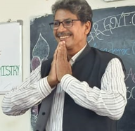

' చెర ' చరవాణి | By Dr.V.Saleem Basha., Principal.
' చెర ' చరవాణి
టెక్స్ట్ బుక్కులు పక్కన పెట్టి
ఫేసు బుక్కున కతుక్కొని..
వాట్సాప్ ఇన్స్టాగ్రామ్
ట్వీటు పిచ్చుకలను గెలుక్కుంటూ..
రియల్ లైఫ్ ను పక్కన పెట్టి
రీలు లైఫ్ని వెతుక్కుంటూ..
చదువుకునే రోజులనుండి
చదువుకొనే రోజుల్లో కి పయనిస్తున్న
ఓ విద్యార్థీ! దేశ భవిత మరిచిపోకు రోయ్

బోటనీ క్లాసు కంటే మ్యాటని ఆటకంటే
ఆపిల్లు ఫోనులోన సీరియళ్ళు చూసుకుంటూ
కొత్త సినిమా లేవేవో "ఐ బొమ్మ" లో తిప్పుకుంటూ
కాలాన్ని వృధా చేయకోయ్
ఓ విద్యార్థీ! నీవు యువ శక్తని మరిచి పోకు రోయ్

అమెజాన్ ఒక వైపు ఫ్లిప్ కార్డు మరో వైపు
మధ్య మధ్యన మీషో షాపు కన్ఫ్యూజన్ చేస్తుంటే
పాకెట్ మనీ షాపింగ్ కు తగలేసేస్తుంటే...
డబ్బులన్నీ వృధా చేయ కోయ్
ఓ విద్యార్థీ! నీవు ఈ దేశపు ఆర్థిక శక్తి అని మరువకోయ్

రిఫరెన్స్ బుక్కుల్లేవు నోటు బుక్కులసల్లేవు
షార్ట్ కట్లు సమ్మరీలు రఫ్ నొట్సులు మరిచినావు
చాట్GPT స్పీచ్ నోట్సు AI ల వెంటపడి
సృజనాత్మకత మరిచిపోకు రోయ్
ఓ విద్యార్థీ! నీవు ఈ దేశపు రామానుజం అని మరువకోయ్

లబ్బు డబ్బు గుండె కాస్త డబ్బు డబ్బని కొట్టుకుంటే
చెట్లు లేక గాలి కోసం ఊపిరాడక చస్తుంటే
శక్తూండీ యుక్తుండీ దేనికీ కొరగాకుంటే
సమాజాన్ని పట్టించుకునే వారెవరు రోయ్
ఓ విద్యార్థీ ! ఓ యువతా!
ఇంకెన్నడు భరతమాత రుణం తీరునోయ్???

Teaching Staff
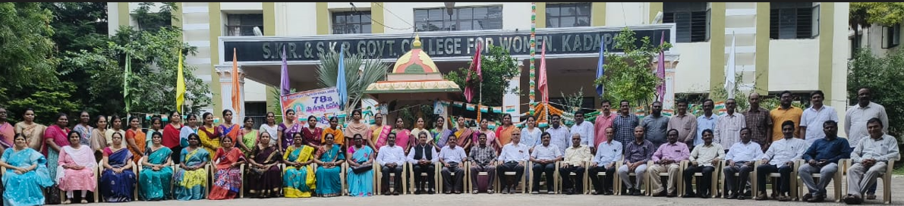
Non Teaching Staff

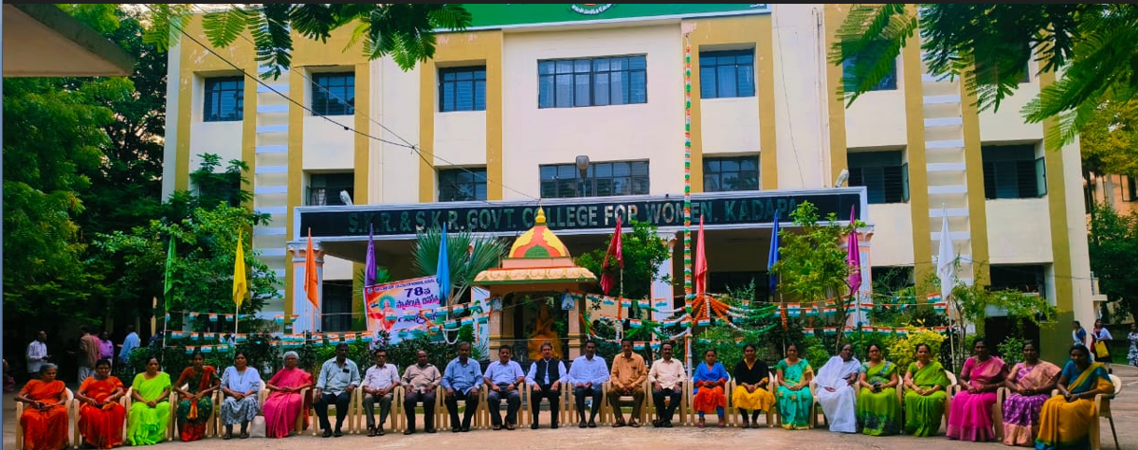
JKC Team

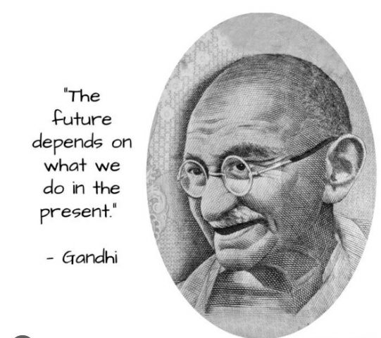
By Maulana Abul Kalam Azad: 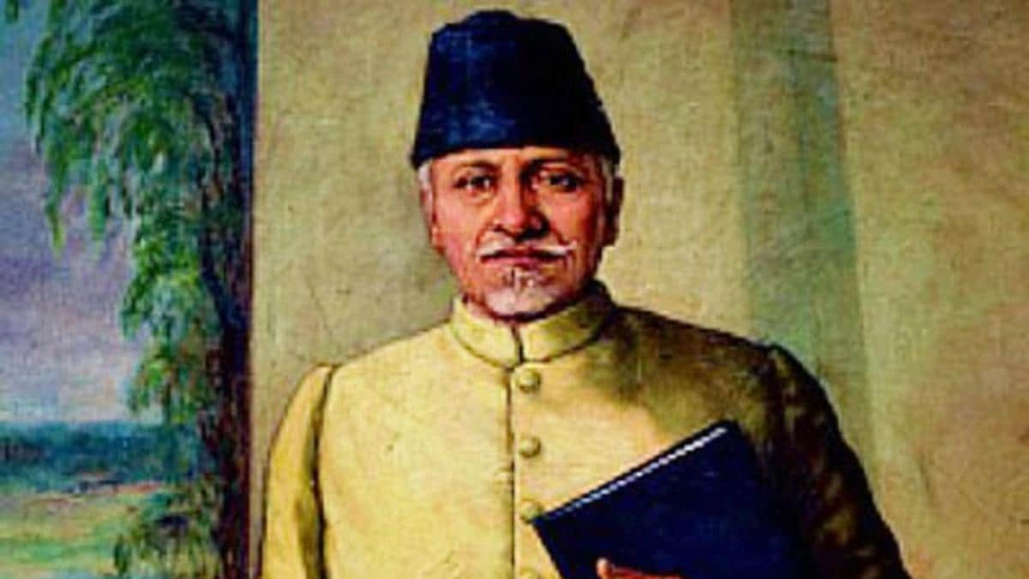
"Educationists should build the capacities of the spirit of inquiry, creativity, entrepreneurial and moral leadership among students and become their role model.”
BY Joyce Banda.
“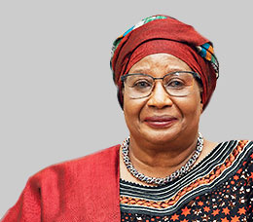
The seeds of success in every nation of the world are best planted by women and their mental support” – Joyce Banda.
By Swami Vivekananda
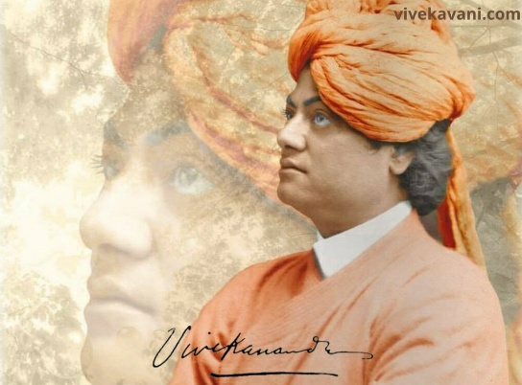“Education is not the amount of information that is put into your brain and runs riot there, undigested, all your life. We must have life-building, man-making, character-making assimilation of ideas.”
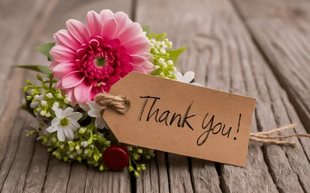 Dr. Shazeeya Begum

